Chapter 2, Solution 3

For silicon, 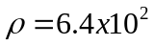Ω-m. 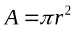. Hence,
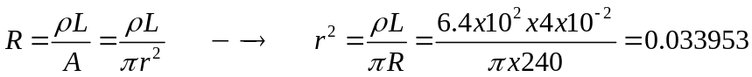

r = 184.3 mm

